What is AWS KMS?
- AWS KMS is a service that helps you create and manage encryption keys.
- These keys are used to protect sensitive data (e.g., passwords, database secrets, files, etc.).
- Instead of writing your own encryption logic, KMS does it for you securely.
Step 1: Open AWS KMS
- Sign in to your AWS Management Console.
- In the search bar, type KMS or Key Management Service.
- Click on Key Management Service.
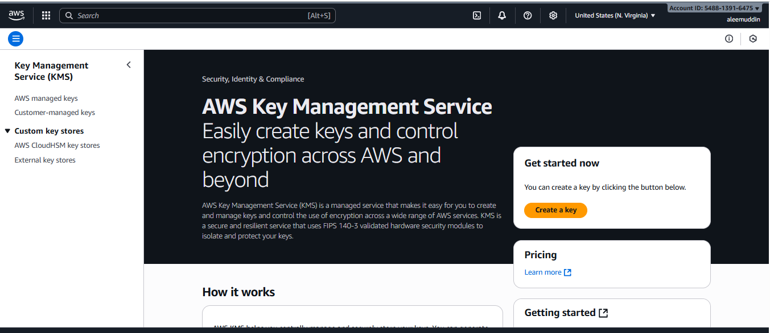

Step 2: Create a New Key
- On the left-hand side menu, click Customer managed keys.
- Click Create key.

Step 3: Select Key Type
- You will see two main options:
  - Symmetric key (most common)
    - Same key is used for encryption and decryption.
    - Example: Encrypting an S3 object or a database password.
  - Asymmetric key
    - One key encrypts, another key decrypts (used for digital signing or special cases).
Choose Symmetric for most cases.

Step 4: Define Key Usage
- Choose what this key will do:
  - Encrypt and decrypt (most common choice).
  - Sign and verify (if using asymmetric keys for signing documents).

Step 5: Set Alias and Description
- Alias: A friendly name to identify your key easily.
  - Example: my-app-secret-key
- Description (optional): Add a short description, e.g.,
  - Key for encrypting database passwords

Step 6: Configure Key Administrative Permissions
- Select which IAM users or roles can manage this key.
- These users can’t use the key to encrypt/decrypt, but they can:
  - Change key settings.
  - Enable/disable the key.
  - Delete the key.
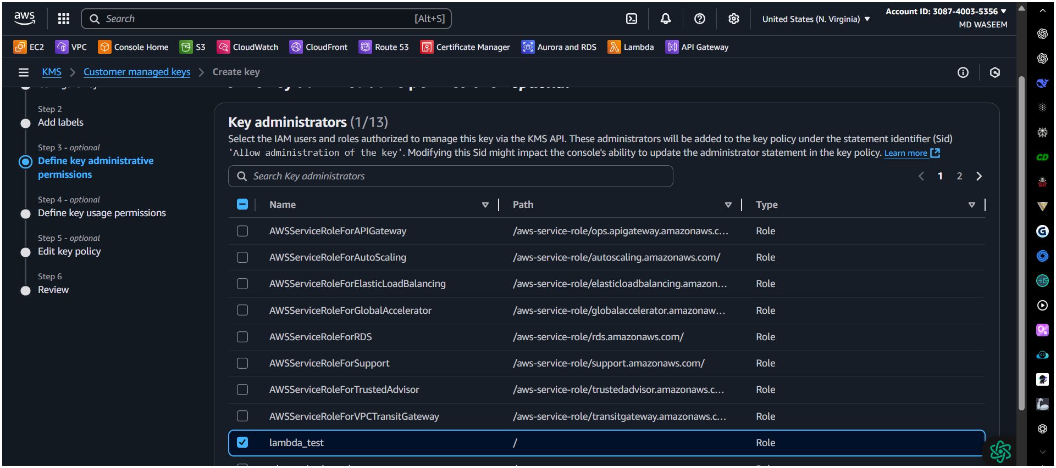

Step 7: Configure Key Usage Permissions
- Select which IAM users, roles, or AWS services can use this key for:
  - Encrypting data.
  - Decrypting data.
- Example:
  - Grant a Lambda role permission to use this key.
  - Grant S3 service access to encrypt your bucket data.
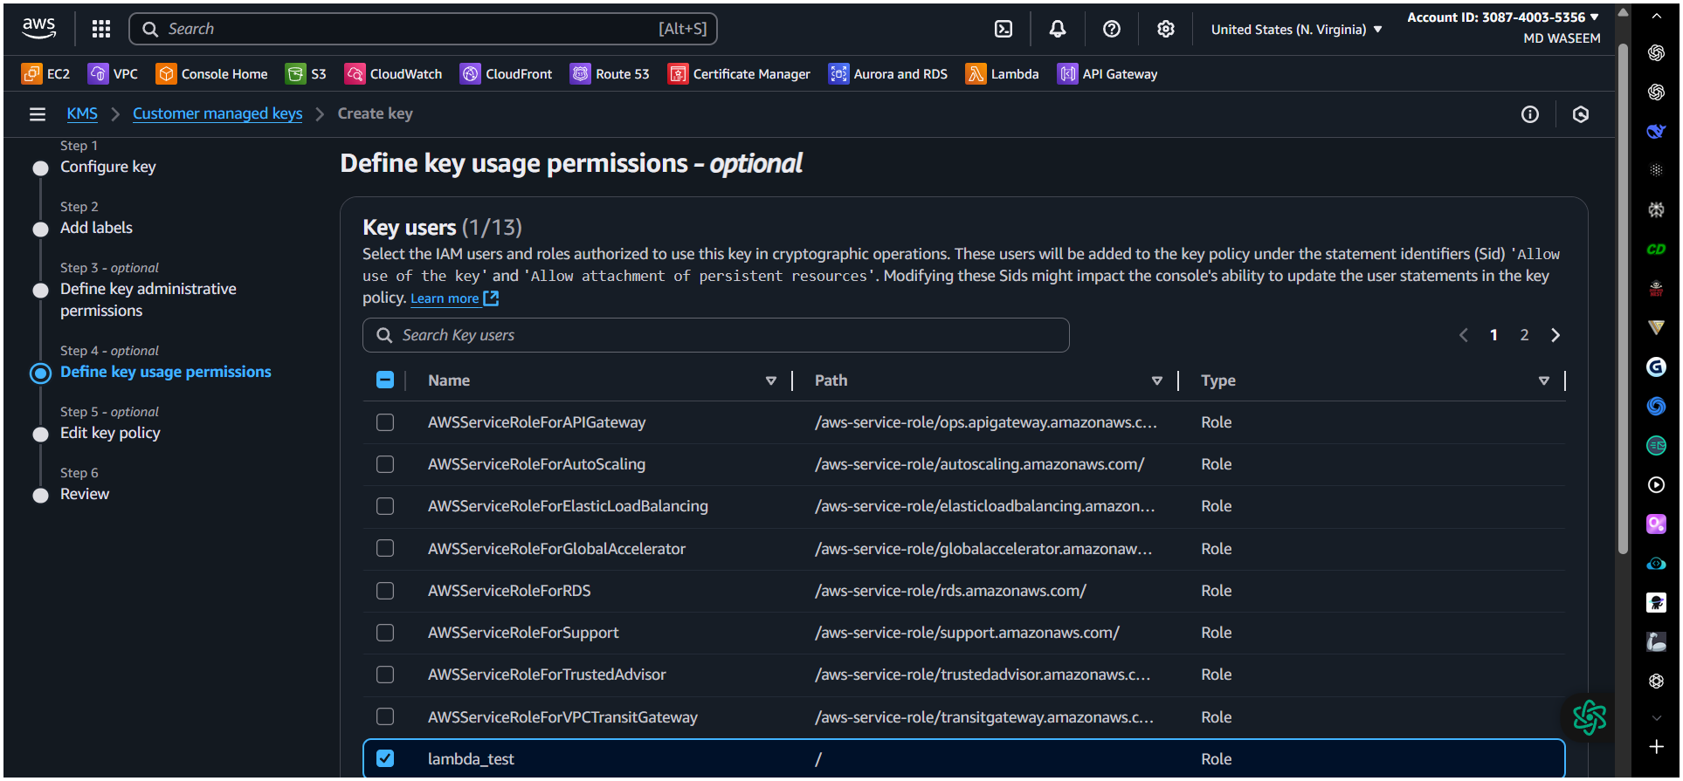

Step 8: Review and Create
- Review all the settings you selected.
- Click Finish or Create key.
- Your new KMS key is now created.
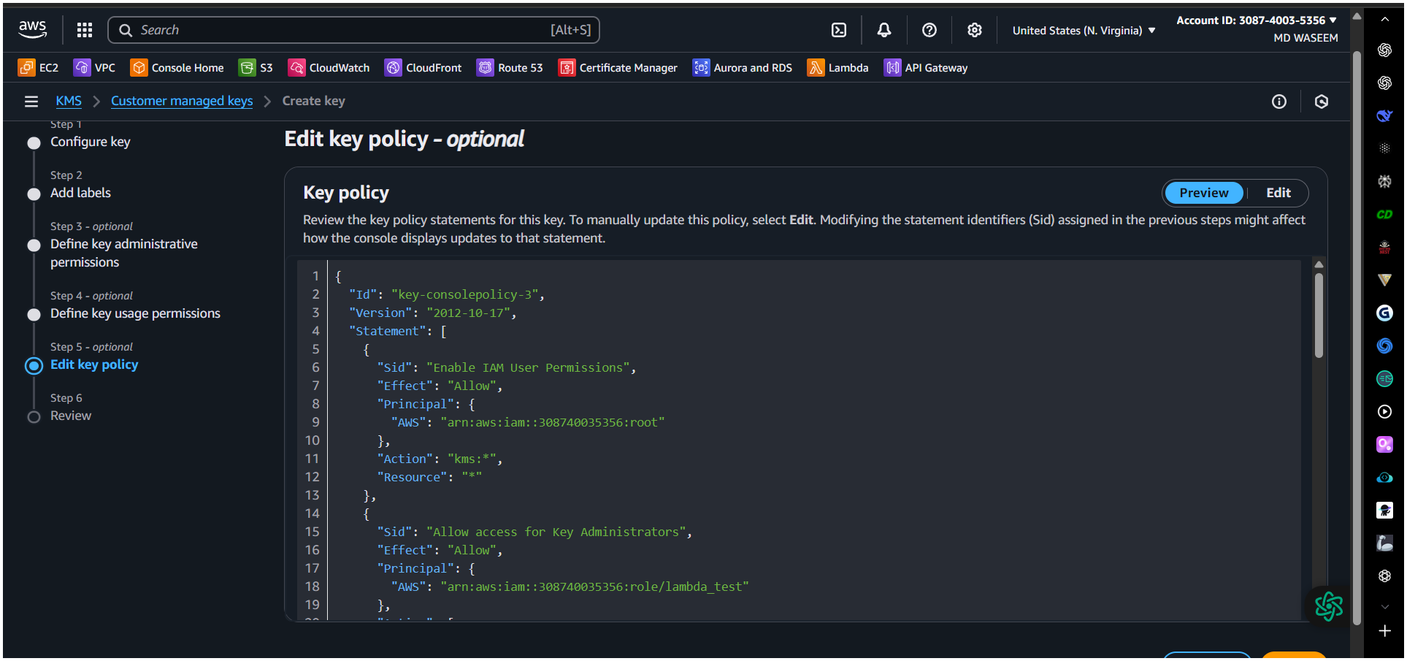
{
"Id": "key-consolepolicy-3",
"Version": "2012-10-17",
"Statement": [
{
"Sid": "Enable IAM User Permissions",
"Effect": "Allow",
"Principal": {
"AWS": "arn:aws:iam::308740035356:root"
},
"Action": "kms:*",
"Resource": "*"
},
{
"Sid": "Allow access for Key Administrators",
"Effect": "Allow",
"Principal": {
"AWS": "arn:aws:iam::308740035356:role/lambda_test"
},
"Action": [
"kms:Create*",
"kms:Describe*",
"kms:Enable*",
"kms:List*",
"kms:Put*",
"kms:Update*",
"kms:Revoke*",
"kms:Disable*",
"kms:Get*",
"kms:Delete*",
"kms:TagResource",
"kms:UntagResource",
"kms:ScheduleKeyDeletion",
"kms:CancelKeyDeletion",
"kms:RotateKeyOnDemand"
],
"Resource": "*"
},
{
"Sid": "Allow use of the key",
"Effect": "Allow",
"Principal": {
"AWS": "arn:aws:iam::308740035356:role/lambda_test"
},
"Action": [
"kms:Encrypt",
"kms:Decrypt",
"kms:ReEncrypt*",
"kms:GenerateDataKey*",
"kms:DescribeKey"
],
"Resource": "*"
},
{
"Sid": "Allow attachment of persistent resources",
"Effect": "Allow",
"Principal": {
"AWS": "arn:aws:iam::308740035356:role/lambda_test"
},
"Action": [
"kms:CreateGrant",
"kms:ListGrants",
"kms:RevokeGrant"
],
"Resource": "*",
"Condition": {
"Bool": {
"kms:GrantIsForAWSResource": "true"
}
}
}
]
}
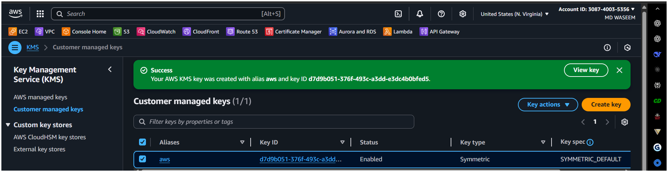

Step 9: Use Your KMS Key
You can now use this key in:
- S3 Buckets – to encrypt files.
- EBS Volumes – for disk encryption.
- RDS Databases – to encrypt database storage.
- Secrets Manager / Parameter Store – to encrypt passwords and API keys.
- Lambda Functions – for encrypting sensitive environment variables.

Example: Using KMS Key with S3 (Basic Example)
- Go to an S3 bucket.
- Upload a file.
- Under Encryption, choose:
  - AWS KMS key (SSE-KMS).
  - Select your newly created key.
This ensures that the file is stored securely using your KMS key.

Benefits of AWS KMS
- Secure encryption without managing keys manually.
- Fine-grained control using IAM.
- Automatic integration with many AWS services.
- Auditing via CloudTrail.

